**Name:**

Last term, we learned that different objects and materials conduct electricity if there is a flow of electrons. Because ions are charged, they can also conduct electricity in the liquid phase

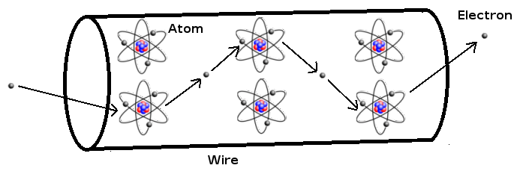

**Aim:** To use electrical conduction to determine whether common household compounds form ions

**Hypothesis:** If the solution contains ______________ (ions/neutral atoms), then it ______________ (will/will not) conduct electricity

**Procedure:**

1. Construct a circuit (in series) using a light bulb, power-pack, and connect the wires to a pair of electrodes like in the picture below: 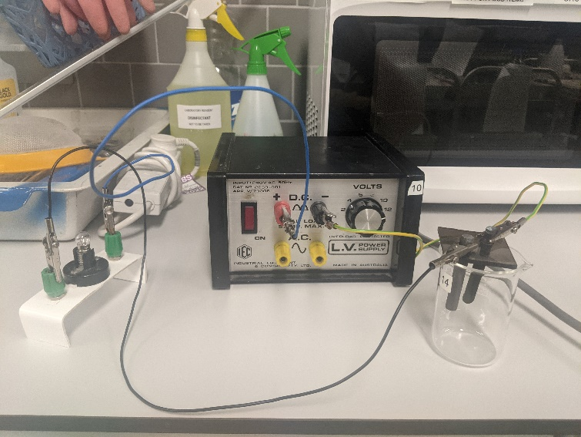
2. Making sure that the power pack is turned off, pour one of the liquids from the results table into the beaker
3. Turn the power-pack on, and rate how bright light bulb is from 0-5, with 0 being off, and 5 being very bright
4. Repeat the experiment for the remaining solutions. If the globe turned on, then the solution contained ions

**Results:**

|  |  |  |
| --- | --- | --- |
| **Solution** | **Brightness (0-5)** | **Does the solution contain ions?** |
| Water |  |  |
| Sugar |  |  |
| Salt |  |  |
| Tea |  |  |
| Coffee |  |  |
| Vinegar |  |  |
| Vegetable Oil |  |  |
| Copper Sulphate |  |  |
| Iron Sulphate |  |  |

**Questions:**

1. Which solutions had the brightest bulb?

________________________________________________________

1. Which solutions do you think contained more ions, and why?

________________________________________________________

________________________________________________________

________________________________________________________

1. Where there any solutions that caused the bulb to light up that should not have? Why do you think this happened? (consult your teacher for solutions that should not have worked)

________________________________________________________

________________________________________________________